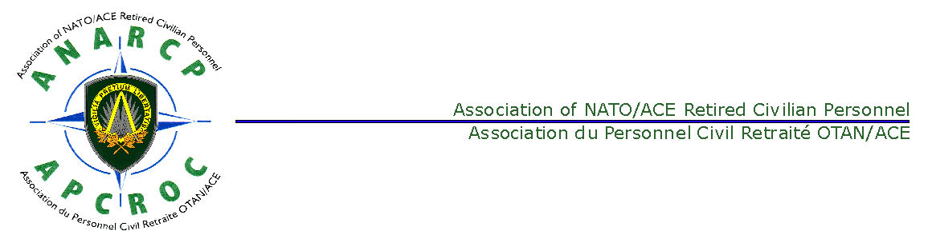

MINUTES OF A MEETING OF THE ANARCP PLENARY COMMITTEE
HELD IN CASTEAU ON TUESDAY 19 MAY 2015

Present:

Peter Ludford Chairman
Hessel Rutten Vice Chairman
Laurie Daykin Secretary
Jean Delor Treasurer
Falko Bϋlling Member
Robert Moriau Member
Jean Vanderwal BEL NATRep
Lis Jensen DNK NatRep
Gunter Franzreb FRA NatRep
Graham Robertson FRA Dep NatRep
Doug Manocha GBR NatRep
Denis Rait GBR Dep NatRep
Vincenzo Arzeni ITA NatRep
Jelle Batstra NLD NatRep
Jan Eiken NOR NatRep
Torstein Hammargren NOR Dep NATRep
Atilla Aktuglu TUR NatRep
Ayhan Egribozlu TUR Dep NatRep

ITEM 1 - Opening Remarks
1. The Chairman welcomed those attending the Plenary Meeting. He informed the meeting that the Patron of the ANARCP, MGEN Fernando Alejandre (SPA), Deputy COS Resources at SHAPE, would attend and address the Annual General Assembly (AGA) on 20 May 2014. The Chairman announced that the Honorary President (Mr John Freeman) was currently in hospital with a serious physical condition and that he would therefore miss the Plenary Meeting and the AGA.

ITEM 2 - Approval of the Agenda
2. The Agenda was reviewed and approved.

ITEM 3 - Approval of the Minutes of the Plenary Meeting of 23 Oct 2014
3. The minutes were reviewed, and the following action items were addressed:

- Minutes Item 4b - ACO Directive 50-1. Mr Bűlling stated that ACO Directive 50-13 had been promulgated on 7 May 2015. An extract of the pertinent section of the documents is at Annex A. Action Closed
- Minutes Item 5 - Bye-Laws. The Chairman stated that the draft Bye-Laws had been amended and the amended version presented to the Plenary Meeting in October. These had been agreed by the Plenary Meeting, with a few minor editorial changes. He further elucidated on the subject by explaining that the proxy vote had been conducted. Action Closed
- Minutes Item 6 – Financial Matters - Tax Exemption on ANARCP Accounts. With regard to the issue of tax exemption on ANARCP accounts, the Treasurer indicated that he’d written to the Legal Advisor without responses. He agreed to investigate further the issue together with ARO. Action – Treasurer
- Minutes Item 6 – Financial Matters – Life Membership. The Secretary indicated that in accordance with the decision of the AGA in May 2014, the granting of new Life Memberships had ceased. Action Closed
- Minutes Item 8 – NATReps – Turkey. Mr Aktuglu stated that he feared that because no internet had been provided to the Turkish NATRep in their office in the Izmir HQ, the office would also be taken from them. After discussion, it was later agreed not to aggravate the situation by requesting the ANARCP Chairman to write again to the Chief of Staff Izmir.
- Minutes Item 9 – Website. Mr Vanderwal stated that Mrs Christine Johnson had been asked to take on the role of Web Manager and had accepted. The Chairman also stated that he would make an additional report on the subject of the website later in the meeting. Action Closed

The minutes of the last meeting were approved.

ITEM 4 - Staffing
4. Proxies and Voting. The Chairman reminded the meeting that in accordance with motion approved at the AGA of 23 May 2014, a quorum for voting would now be an absolute number of 100 members voting (Present or proxy).

5. Bye-Laws. The Chairman reported that the revised Bye-Laws were the first item to be voted on under the new quorum of 100. The Secretary stated that there had been 171 votes by E Mail and proxy. (169 Agree 2 Disagree). The Chairman thanked the NATReps for their efforts in soliciting responses.

ITEM 5 - Financial Matters
6. The Treasurer reported that he had circulated the Treasurer’s Report and financial statements. He stated that the ANARCP was in good financial health with approximately 150,000 EUR in credit. He would provide a report to the AGA on 20 May 2015. The Treasurer further pointed out that there was a possibility that the annual contribution of 2 Euro to the Confederation to support its general operation and the website might not be enough and we may be asked for an additional contribution in the future. Some members indicated that the Confederation should be more open with regard to its budget, part of which came from the ANARCP. It was further agreed that the ANARCP should be more critical of the Confederation and in future, an update from the Confederation would be useful. After further discussion, the Chairman agreed to write to the Chairman of the Confederation requesting a justified budget. Action: Chairman, Secretary

ITEM 6- Updates
8. Salary/Pensions. The Chairman explained that salaries had been adjusted. However, the method of adjustment would be discussed again in 2017. The subject of the introduction of the ‘Single Spine’ was discussed and, with the absence of Grade ‘Steps’, how this might affect pensions. It seemed certain that the single spine would be adopted. The location of the NATO Pensions unit was discussed. Mr Bϋlling confirmed that the NATO Pensions unit would remain in Brussels and not be merged with a similar unit for the other coordinated organisations at the OECD in Paris.

9. Allianz Worldwide Care Issues. The Chairman introduced the topic, indicating that he thought that the service provided by AWC had improved, and that there were fewer general difficulties. Most issues were of a personal nature. Mr. Bϋlling stated that the NATO Group Insurance contract is being rewritten and will be finished this year. A revised claim form would also be produced. This would be the subject of a briefing at the AGA on 20 May 2015.

10. Confederation Issues.

- The Chairman indicated that the issue of the legitimacy of the NATO Administrative Tribunal vis a vis International human rights law and national law had been discussed. It appeared that NATO had little regard for national or international law (For a layman’s reading on international law, please see: http://en.wikipedia.org/wiki/International_human_rights_law)
- The issue of definition of ‘spouse’ and ‘partnership’ was discussed. The latter is not recognised by NATO. It was thought that these definitions should be within the jurisdiction of national matter and not one for NATO to set its own law.
- The Confederation website is now 98% complete and would go live soon. (After meeting note: The site is now up and running and all members with an email address have been informed.)
- The Chairman stated that the pension unit will, in future, include relevant changes in regulations affecting pensioners with the pension slips.
- The Chairman stated that the Chairman of the CNRCSA had written to the Secretary General who is the Honorary Chairman of the Confederation. He had received no response and appeared to be too busy.

ITEM 7 - Local/National Activities.
12. The Chairman suggested that the NATRep’s reports be included in both the Plenary and AGA Minutes but that on essential issues be brought up at the Plenary Meeting. The subject of a template format for NATReps was again raised and the Secretary agreed to draft one and to circulate it to the NATReps for comment. It was agreed that the NATreps reports would be given at the AGA the following day and included in the minutes of that meeting.

ITEM 8 – WebSite.
13. The Chairman reiterated that the current website was in urgent need of updating. However, because of the development of the Confederation website this had been purposely delayed. The majority of information of interest to retirees would be held on the Confederation website and the minimum required would be placed on the revised ANARCP website. There should be no duplication. There would be an ‘Open’ and ‘Private’ part to both websites.

ITEM 9 - Administrative Matters.
14. The Chairman and Secretary provided information regarding the dinner that evening and the lunch at the AGA on 20 May 2015.

ITEM 9 - Any Other Business.
Mr Bϋlling suggested that an extract to ACO Directive 50-13 be included as an attachment to the minutes. This was agreed.

ITEM 10- Date of Next Meeting
16. It was agreed that the next ANARCP Plenary Meeting would be on Thursday 22 Oct 2015.

P LUDFORD 30 May 2015
Chairman ANARCP

Annex A:
ACO Directive 50-13 – Extract
Annex A
ACO Directive 50-13 – Extract
